УО «Белорусский государственный университет информатики и радиоэлектроники»

Кафедра ПОИТ

Отчет по лабораторной работе №6.1

по предмету «Основы алгоритмизации и программирования»

Вариант 4

Выполнил:

Бражалович А. И.

Гр. 351004

Проверил:

Данилова Г. В.

Минск 2024

**Задание:**

Анимация. Составить программу вывода на экран дисплея изображения летящей птицы. Стрелками (вправо, влево, вверх, вниз) регулировать полёт.

**Код программы Delphi:**

Unit MainForm;

Interface

Uses

Winapi.Windows, Winapi.Messages, System.SysUtils, System.Variants,

System.Classes, Vcl.Graphics,

Vcl.Controls, Vcl.Forms, Vcl.Dialogs, Vcl.Menus, Instruction, Developer,

Vcl.StdCtrls, Vcl.ExtDlgs, Vcl.Grids, Vcl.ExtCtrls, Vcl.Imaging.Pngimage;

Type

// BirdSt = Array [0..1] Of Integer;

TMainTaskForm = Class(TForm)

MainFormMenu: TMainMenu;

FileMenu: TMenuItem;

InstructionMenu: TMenuItem;

DeveloperMenu: TMenuItem;

N1: TMenuItem;

QuitMenu: TMenuItem;

BackGroundImage: TImage;

BirdImage: TImage;

Timer: TTimer;

Procedure DeveloperMenuClick(Sender: TObject);

Procedure InstructionMenuClick(Sender: TObject);

Function FormHelp(Command: Word; Data: NativeInt;

Var CallHelp: Boolean): Boolean;

Procedure FormCloseQuery(Sender: TObject; Var CanClose: Boolean);

Procedure QuitMenuClick(Sender: TObject);

Procedure ShowBird(Index: Byte);

Procedure FormCreate(Sender: TObject);

Procedure TimerTimer(Sender: TObject);

Procedure FormKeyDown(Sender: TObject; Var Key: Word;

Shift: TShiftState);

Private

{ Private declarations }

Public

{ Public declarations }

End;

Var

MainTaskForm: TMainTaskForm;

BirdSt: Array [0 .. 1] Of String;

CurrPosition: Byte;

DownRightPath: String;

UpRightPath: String;

DownLeftPath: String;

UpLeftPath: String;

Implementation

{$R *.dfm}

Procedure TMainTaskForm.DeveloperMenuClick(Sender: TObject);

Var

DeveloperForm: TDeveloperForm;

Begin

DeveloperForm := TDeveloperForm.Create(Self);

DeveloperForm.ShowModal;

DeveloperForm.Free;

End;

Function TMainTaskForm.FormHelp(Command: Word; Data: NativeInt;

Var CallHelp: Boolean): Boolean;

Begin

CallHelp := False;

InstructionMenuClick(Self)

End;

Procedure TMainTaskForm.FormKeyDown(Sender: TObject; Var Key: Word;

Shift: TShiftState);

Begin

If (BirdImage.Top < 0) And (Key = VK_UP) Then

Key := 0;

If (BirdImage.Top + BirdImage.Height > MainTaskForm.ClientHeight) And

(Key = VK_Down) Then

Key := 0;

If (BirdImage.Left < 0) And (Key = VK_Left) Then

Key := 0;

If (BirdImage.Left + BirdImage.Width > MainTaskForm.ClientWidth) And

(Key = VK_Right) Then

Key := 0;

Case Key Of

VK_LEFT:

Begin

BirdSt[0] := DownLeftPath;

BirdSt[1] := UpLeftPath;

BirdImage.Left := BirdImage.Left - 10;

End;

VK_RIGHT:

Begin

BirdSt[0] := DownRightPath;

BirdSt[1] := UpRightPath;

BirdImage.Left := BirdImage.Left + 10;

End;

VK_UP:

Begin

BirdImage.Top := BirdImage.Top - 10;

End;

VK_DOWN:

Begin

BirdImage.Top := BirdImage.Top + 10;

End;

End;

End;

Procedure TMainTaskForm.InstructionMenuClick(Sender: TObject);

Var

InstructionForm: TInstructionForm;

Begin

InstructionForm := TInstructionForm.Create(Self);

InstructionForm.ShowModal;

InstructionForm.Free;

End;

Procedure TMainTaskForm.QuitMenuClick(Sender: TObject);

Begin

Close;

End;

Procedure TMainTaskForm.FormCloseQuery(Sender: TObject; Var CanClose: Boolean);

Var

Confirmation: Integer;

Begin

Confirmation := Application.MessageBox('Вы действительно хотите выйти?',

'Выход', MB_YESNO + MB_ICONQUESTION + MB_DEFBUTTON2);

CanClose := Confirmation = IDYES;

End;

Procedure TMainTaskForm.FormCreate(Sender: TObject);

Var

BackGroundPath: String;

Begin

DownRightPath := ExtractFilePath(Application.ExeName) + 'Images\downRight.png';

UpRightPath := ExtractFilePath(Application.ExeName) + 'Images\upRight.png';

DownLeftPath := ExtractFilePath(Application.ExeName) + 'Images\downLeft.png';

UpLeftPath := ExtractFilePath(Application.ExeName) + 'Images\upLeft.png';

BirdSt[0] := DownRightPath;

BirdSt[1] := UpRightPath;

BackGroundImage.Width := MainTaskForm.Width;

BackGroundImage.Height := MainTaskForm.Height;

CurrPosition := 0;

Timer.Interval := 300;

End;

Procedure TMainTaskForm.ShowBird(Index: Byte);

Begin

BirdImage.Picture.LoadFromFile(BirdSt[Index]);

End;

Procedure TMainTaskForm.TimerTimer(Sender: TObject);

Begin

if CurrPosition = 100 then

CurrPosition := 0;

ShowBird(CurrPosition Mod 2);

Inc(CurrPosition);

End;

End.

**Скриншоты:**

**Delphi:**

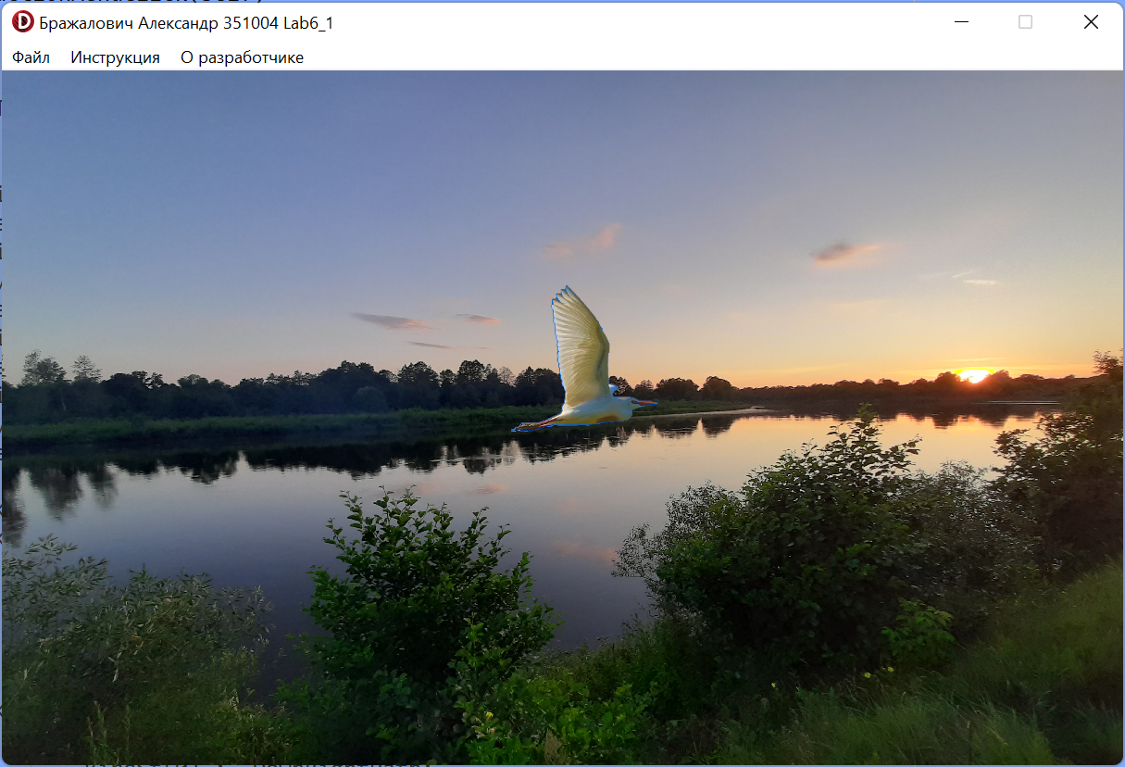

**Блок-схема:**

